Campervan passion: Laika launches two new Ecovip Campervans

San Casciano in Val di Pesa, June 2021 - Laika expands its range of Campervans by introducing two new Ecovip Campervans. The two new layouts are both on Fiat Ducato 33 Light chassis: the Ecovip Campervan 540, with a length of 541 cm, has a transverse double rear bed. The Ecovip Campervan 600, with a length of 599 cm and a transverse double rear bed, is equipped with the new Vario-Bathroom, with the washbasin wall that swivels to create a separate shower.

AN ATTRACTIVE LOOK, PLENTY OF LIGHT AND GREAT INSULATION

The new Ecovip Campervans are available in four exterior colours: white, pastel grey, aluminium grey and metallic black. The eye-catching black and copper graphics are a perfect match for the ultra-flat, aluminium-framed windows with their automotive look. As many as 3 windows are dedicated to the rear sleeping area (as standard). In addition, the Skyview is available as an option on all models as an alternative to the raising pop-top roof with double bed.

Ecovip Campervans have an innovative full insulation system with Ecofiber 40, an insulation material made of polyester fibres and a protective aluminium layer, which completely covers the vehicle and prevents heat loss. In addition, the roof and floor are insulated with XPS. Insulation is also extended to the rear doors and the side door, for maximum protection from the cold even in the areas that are usually most exposed to cold drafts.

ELEGANT INTERIOR DESIGN

The interior design, materials and finishes are in line with the rest of the Ecovip range. Also, for the Campervans, the furniture is available in the warm "Moka oak" (standard) or the lighter "Tuscan pear" woods. The elegant wall units with metal handles continue into the driver's cab, giving the interior continuity and harmony. As with the rest of the Ecovip range, the table and kitchen tops are embellished with elegant copper edging and the drawers feature convenient retractable handles.

In the living area, the depth-adjustable sofa with adjustable backrest inclination (with Isofix as standard) ensures maximum comfort both when stationary and when travelling. The fabrics of the seats and backrests can be combined to suit your taste and to match the cushions. The peninsula integrating the 19" TV compartment with indirect lighting is ideal for those who love watching their favourite shows even on holiday. The wall-mounted table can be folded down, and its surface area can be folded open if necessary, so as not to take up space when travelling. Direct and indirect lighting ensures a high living comfort even at night, thanks also to reading lights with integrated USB sockets. The double floor at the front of the vehicle also allows the storage of bulky loads and provides an additional element of insulation.

PRACTICAL SOLUTIONS IN EVERY ENVIRONMENT

Every detail of the kitchen has been thought through: the additional worktop with folding shelf and the two open compartments underneath provides the necessary space for cooking in comfort. The maxi-drawer and the two lower drawers allow you to store supplies, pots and pans, and everything you need for cooking. The 90-litre refrigerator is standard (on Ecovip 600), while the 138-litre refrigerator is available as an option.

In the bathroom, the standard window on all Ecovip model Campervans not only provides more air and light, but also allows you to use the shower from outside, with either hot or cold water. The Ecovip 600 Campervan also features the new Vario-Bathroom: the washbasin wall rotates to form a separate shower.

A DREAMY SLEEPING AREA

In the sleeping area, the rear bed has an elegant, upholstered headboard and a bed base with hinged slats throughout the bed with double bottom support. This ensures stability and comfort during the sleeping hours. Access to the bed is made easy by the retractable sliding step (on Ecovip 600). The maxi-garage with a useful height of 65 cm and a double bottom with removable top allows you to store all the necessary items neatly. The storage space is also enhanced by the wall units and the compartment under the bed.
Indirect and dimmed lights provide a warm and restful atmosphere. The swivelling reading lights complete with USB socket allow mobiles and tablets to be conveniently charged. The three rear windows (two at the back and one on the left side) provide airiness and natural light.

CAMPERVAN FOR ALL SEASONS

The Ecovip Campervans are suitable for all temperatures, thanks to the 6 kW ducted warm air heater. Optional gas + electric or diesel + electric heater is also available. Heat distribution is optimised to cover all areas of the vehicle, from the driver's cab to the rear area. In addition, the grey water recovery tank is insulated and heated (included with the basic package). Confirming the high heating and insulation capacity of the new Campervans, the Ecovip 600 successfully passed the climate chamber test according to EN 1646-1. Starting from an internal and external temperature of -15°C, insulation and heating enable each area inside the vehicle to reach a minimum temperature of 20°C in just 2 hours and 21 minutes!

ECOVIP 540 CAMPERVAN

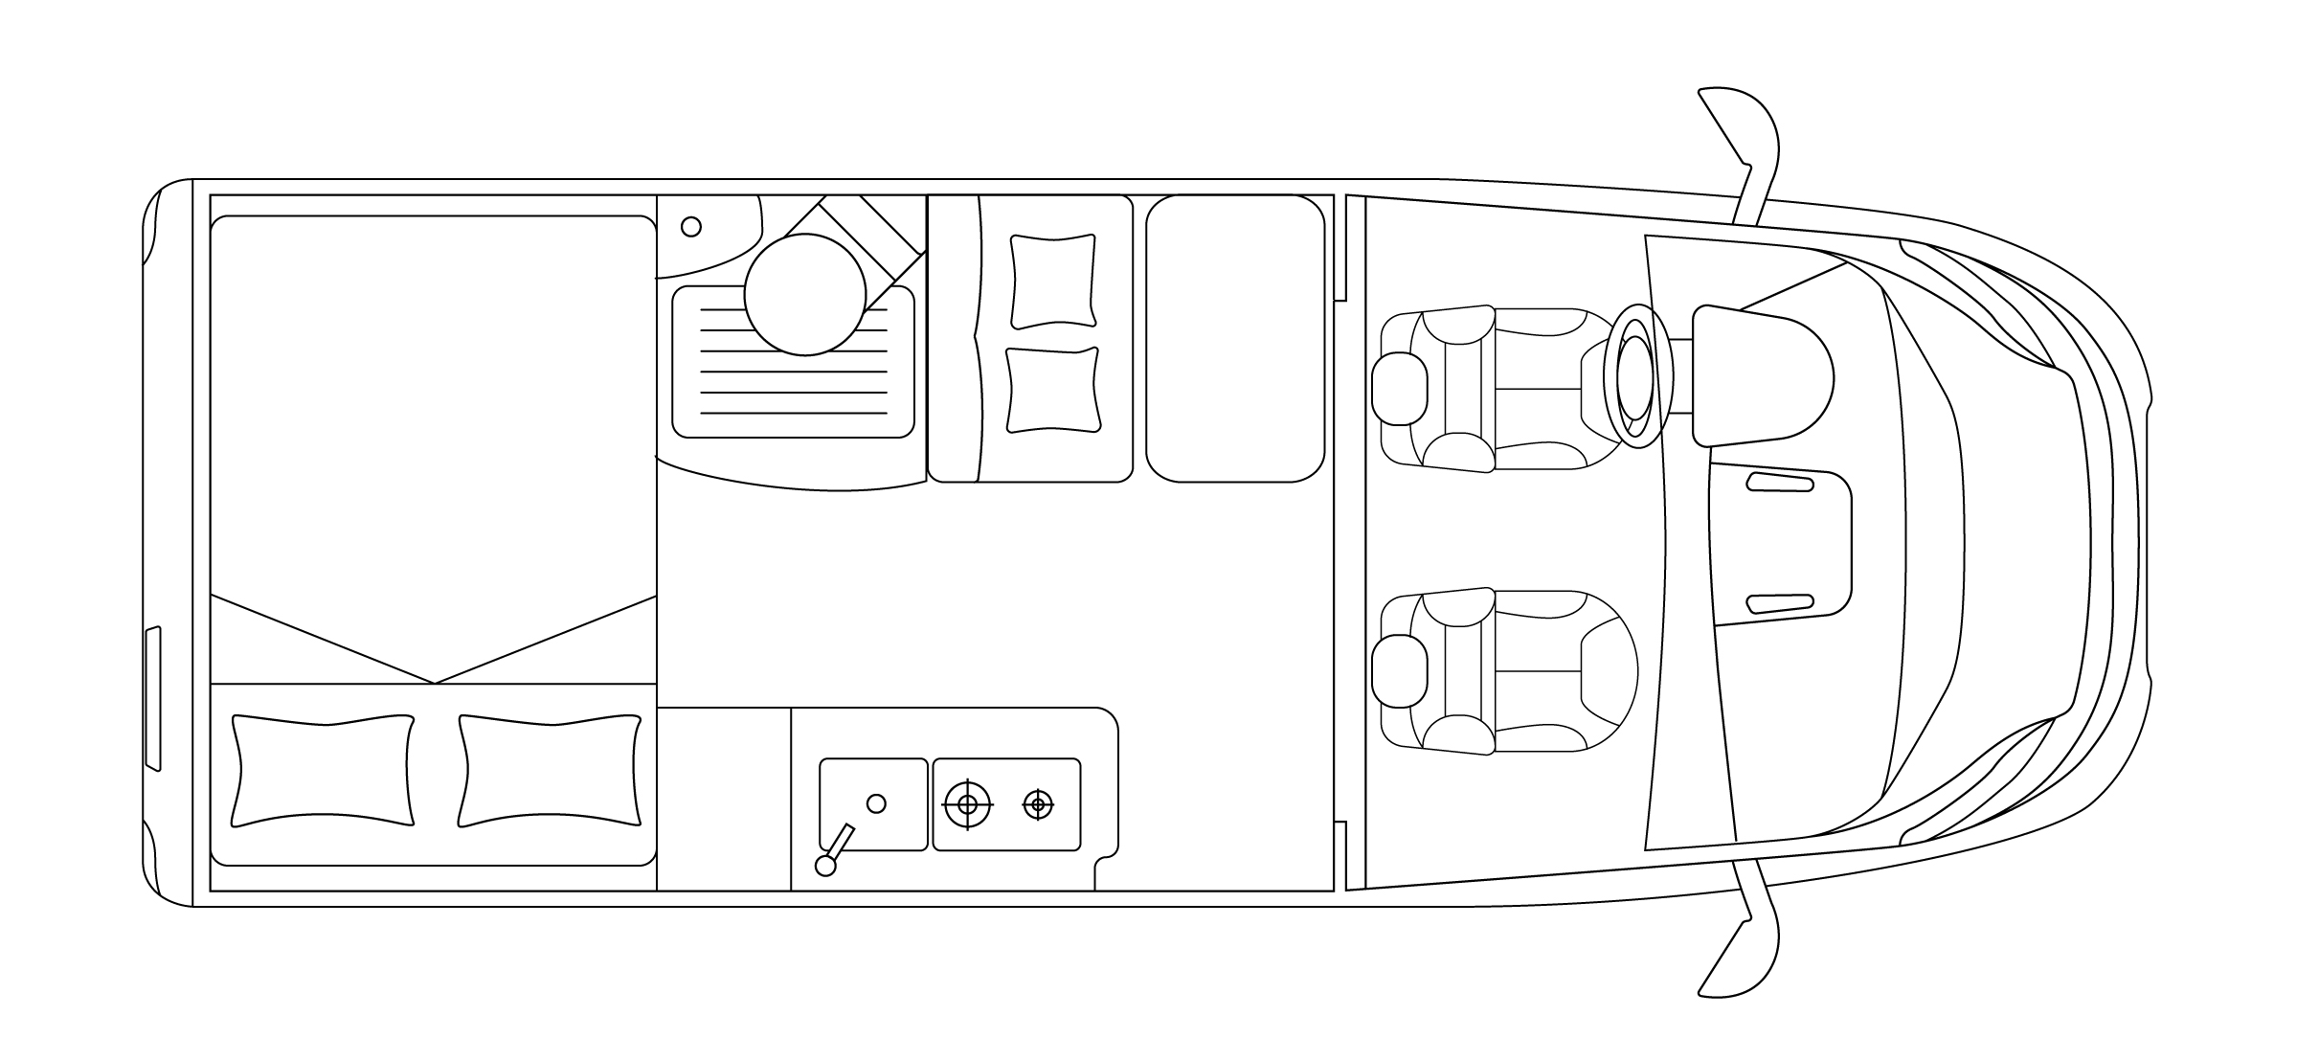
Fiat Ducato 33 Light 120 HP
Length/Width/External height: 541/205/270 cm
Approved seats: 4 (S)
Sleeps: 2 (S) + 2 (opt)
Rear double bed: 196 x 132 max./120 min. cm
Bed on raising retractable roof (opt): 200 x 135 cm
70 L Refrigerator
Ducted air heater 6 kW

ECOVIP 600 CAMPERVAN

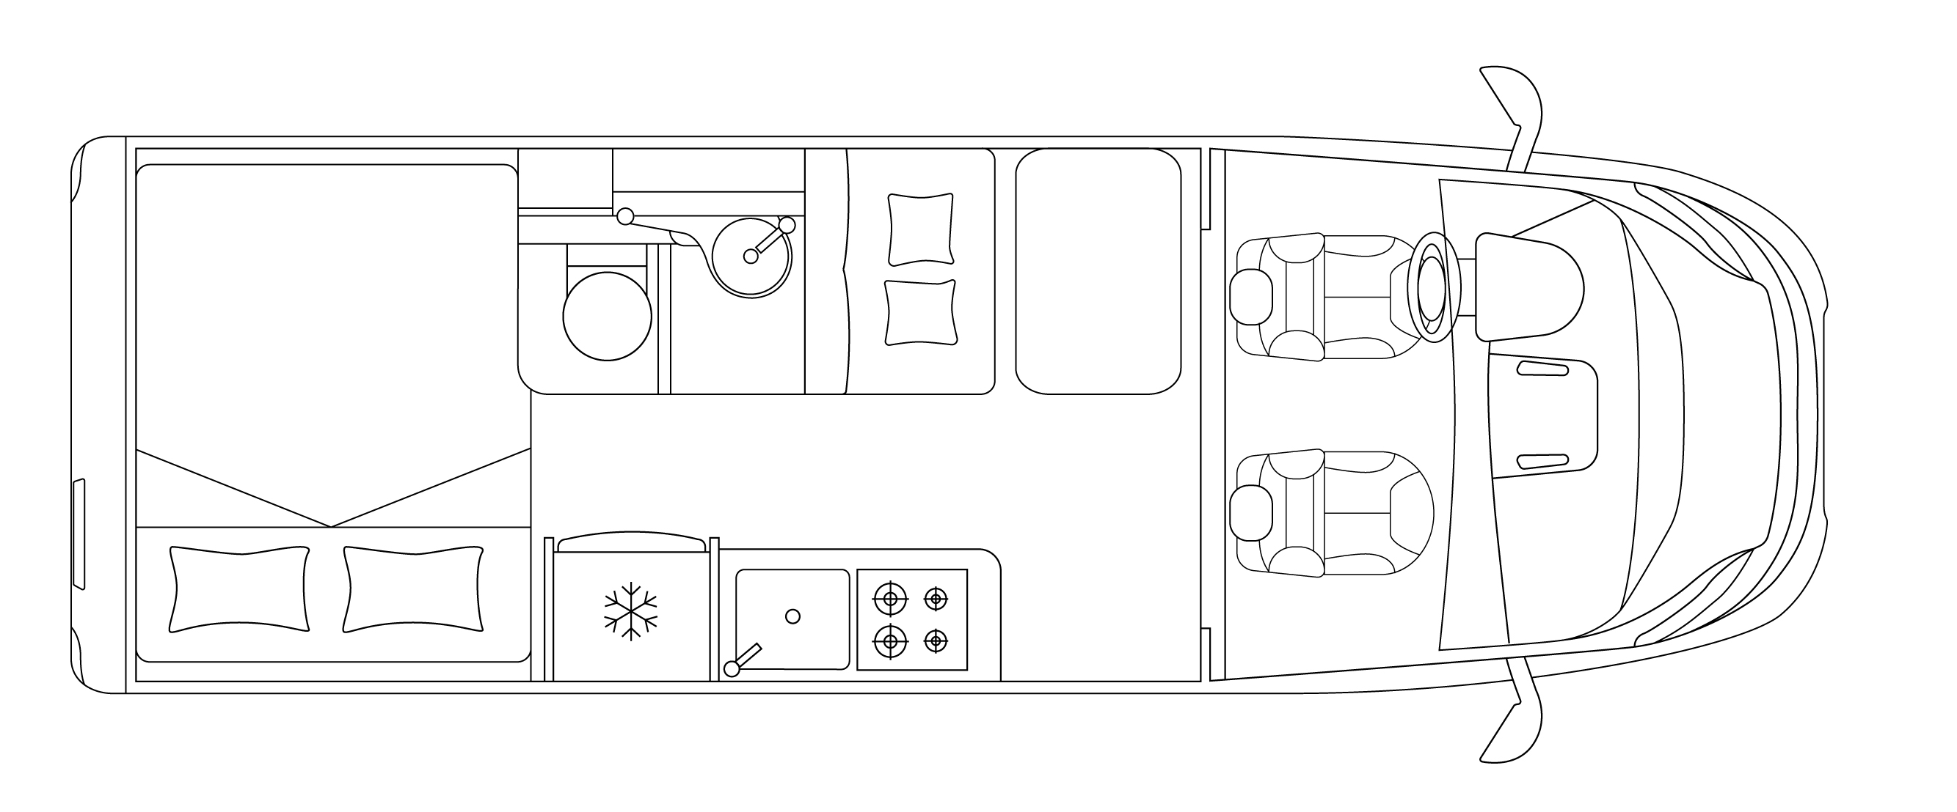
Fiat Ducato 33 Light 120 HP
Length/Width/External height: 599/205/270 cm
Approved seats: 4 (S)
Sleeps: 2 (S) + 2 (opt)
Rear double bed: 196 x 150 max./138 min. cm
Bed on raising retractable roof (opt): 200 x 135 cm
Vario-Bathroom
90 L Refrigerator
Ducted air heater 6 kW

Contacts: Flavia Lazzaro flavia.lazzaro@laika.it

TRAVELLING WITH YOU SINCE 1964
57 years have passed since, in 1964, Giovanbattista Moscardini founded LAIKA, naming it after the first dog in space. Fascinated by the adventure of space and the new horizons that were opening, Moscardini lay the foundations for the cutting-edge company of today, which is distinguished by its designer production and excellent construction technique. Part of the Erwin Hymer Group, Laika Caravans creates vehicles designed with state-of-the-art construction techniques, made to last and designed for all climates. Customer satisfaction is the key objective of Laika, which thanks to its team – with a long history of competence and experience – creates vehicles where attention is paid to the smallest detail. www.laika.it

ERWIN HYMER GROUP
The Erwin Hymer Group is a 100 percent subsidiary of Thor Industries, the world's leading manufacturer of recreational vehicles with more than 25,000 employees worldwide. The Erwin Hymer Group unites motorhome and caravan manufacturers as well as motorhome and caravan accessory specialists, hire and financing services under one roof. The motorhome and caravan brands Buccaneer, Bürstner, Carado, Crosscamp, Compass, Dethleffs, Elddis, Eriba, Etrusco, Hymer, Laika, LMC, Niesmann+Bischoff, Sunlight and Xplore, the motorhome rental companies Crossrent, McRent and rent easy, and also the chassis specialist Goldschmitt, the accessories specialist Movera and the touring portal freeontour all belong to the Erwin Hymer Group. Further information is provided at www.erwinhymergroup.com

